Contents
Contents i
1. Introduction 3
1.1 Naming convention 3
Process overview 4
Refresh description 5
1.2 Database preparations 5
1.3 ContentServer 10.0 refresh 6
1.3.1 Copy ContentServer files from PRODuction (CL08-PBS-EIB) 6
1.3.2 Backup files on server to be refreshed 6
1.3.3 Refresh JBoss WAR files 7
1.3.4 Refresh files 7
1.3.5 Changes in opentext.ini – correct all entries linked to PRODuction (correct ports / pathes / urls …) (to be reviewed) 7
1.3.6 WebDAV path correction: 9
1.3.7 Database Data Changes 10
1.3.8 Refresh the required EFS files (manual) 11
1.3.9 Refresh the required EFS files (automated - to be reviewed) 11
1.3.9.1 Refresh_input_file_generator_<version>.bash (to be reviewed) 11
1.3.9.2 Refresh_tar_file_generator_<version>.bash (to be reviewed) 12
1.3.9.3 Refresh_untar_<version>.bash (to be reviewed) 12
1.4 Post installation tasks 13
1.4.1 Clean up of folders - if required 13
1.4.2 Start ContentServer Services 13
1.4.3 Setup DB connection (Already done in 3.3.3.1 (4.)) 14
1.4.4 Change passwords (Admin, Interface-Account and set special User-Rights) 14
1.4.5 Change SerapisGEDXML configuration 15
1.4.6 Change ForcePrets configuration 15
1.4.7 Change Sharepoint Documents GED Interface configuration 16
1.4.8 Change Pic configuration 16
1.4.9 Change MultiFileOutput configuration 16
1.4.10 Change MultiAgent configuration 16
1.4.11 Change SPDocsGedInterface configuration 17
1.4.12 Change DFT connection string (Already done in 3.3.3.1 (4.)) 17
1.4.13 Update database connection for Webform database lookup 18
1.4.14 Anonymize database 18
1.5 On UAT and DEV Create backup Admin server 19
1.6 Create 1st ContentServer Front-end (UAT and DEV only) 20
1.6.1 Create 1st ContentServer Front-end 20
1.6.2 Run Chris's script - See Appendix A 20
1.6.3 Run Chris's script - See Appendix A 20
1.6.4 Restart ContentServer 21
1.6.5 Enable Load Balancer 21
1.7 Create Indexes 21
Change Storage Provider Settings - Configure Storage Rules 21
1.7.1 Check port numbers for new services 22
1.7.2 Configure DCS 22
1.7.3 Configure RMI 23
1.7.4 Create indexes 24
1.7.4.1 Enterprise index 24
1.7.4.2 User Help index 26
1.7.4.3 Admin Help index 26
1.7.5 Creating Admin server entries 27
1.7.6 Enable Notifications 27
1.7.7 Create/update Slices 27
1.8 Cluster Control (UAT only) (NEEDS WORK) 28
1.8.1 Cluster operation and monitoring tests 28
1.8.2 Cluster operation and monitoring tests 28
1.9 Start and test Kofax 29
1.10 Start and test Mercator 29
1.11 Verify system 29
1.12 Enable Load Balancer (DEV and UAT only) 29
Outstanding issues or changes 30
Appendix A 31
Appendix B dbRefresh.sql 32
Appendix C-1 Refresh_input_file_generator 35
Appendix C-2 Refresh_tar_file_generator 36
Appendix C-3 Refresh_untar 37
Appendix C-4 efsRefresh.sql (manual EFS Refresh) 38
Appendix C-4 anonymize database 40
1.13 Make anonym PWS 40
1.13.1 Rename all objects inside ALL PWS (~ 1500 sec) 40
1.13.2 Rename all filenames of document (144) versions inside all PWS (~ 350 sec) 40
1.13.3 Delete PWS-eMails (~ 450 sec / ~ 1000 sec / ~ 350 sec) 41
1.13.4 Rename all objects inside “07 Control” and “08 Central Services” (WA and KnC) (~ 1500 sec) 42
1.13.5 Rename all versions of objects inside “07 Control” and “08 Central Services” (WA and KnC) (~ 1000 sec) 42
1.13.6 Change eMail addresses of all users to “ot-esp@eib.org” (except users: ‘paukert’, ‘wohner’, ‘horkay’) (~ 1 sec) 43
For additional information, please contact: 44

Introduction
This document describes the procedure for refreshing a ContentServer 9.5.0.1 from DEV to UAT (please consult relevant document for refreshing different scenarios)

Naming convention
The document uses the following naming convention in the WHO field of the tables below:
- SAW means the action is to be performed by SAW AG consultant
- Oracle means the action is to be performed by the EIB Oracle consultant
- Unix means the action is to be performed by the EIB Unix consultant
- Func means the action is to be performed by the EIB Functional ContentServer Administrators
When path settings are used in this document, the following naming convention is used:
- <server> replace this with the instance name
- <user> replace this with the Unix user name
- <Oracle_name> replace this with the Oracle user
- <Oracle_password> replace this with the Oracle password
- <Oracle_system> replace this with the Oracle SID
Example: /global/<server>/livelink/<user>/llhome becomes on <server>: /global/<server>/livelink/<user>/llhome.
Whenever ContentServer 9.5 is mentioned, ContentServer 9.5 SP1 is meant.

Process overview
- Database preparations
  - Ticket to ORACLE-DBA to refresh the desired DB from special PROD status
Create CR ticket for Oracle DBA.
The request includes the need for it to be done from the current day (the day of the DB refresh) at 2:45 AM (backup made during the night).
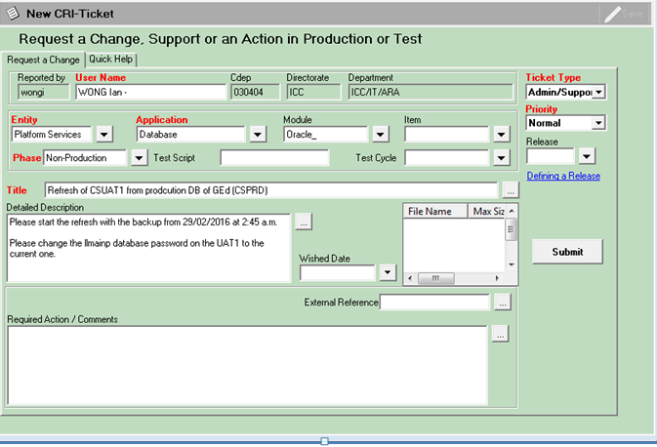
  - Stop all CS10 services link to the DB before DB refresh will be started
Send e-mail to Oracle DBA to inform that a ticket was created.
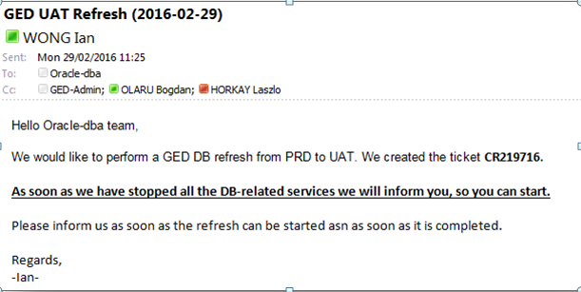
They should be later informed when they can actually start the refresh of the DB.
  - DB refresh by ORACLE-DBA
- ContentServer CS10 refresh : Not applicable to fast refresh
  - Get the ContentServer files (HOME: Opentext) from PROD backend (zipped)
  - Backup the ContentServer files (HOME: Opentext) from SYSTEM to be refreshed
(zipped) and rename the subdirectories:
    - config → config_bkp_<yyyymmdd>
    - module → module_bkp_<yyyymmdd>
    - patch → patch_bkp_<yyyymmdd>
    - support → support_bkp_<yyyymmdd>
  - Refresh JBoss WAR files
    - These are, under normal circumstances, in the <JBoss_HOME>\server\web
  - Refresh the ServerAgent JAR file and check/update the starting script
    - These are, under normal circumstances, in the <serverAgent_HOME>
    - Starting script is also under <serverAgent_HOME> and is called “startAgent.bat”
  - Refresh the ContentServer files (HOME: Opentext) on SYSTEM to be refreshed by ContentServer files (HOME: Opentext) from PROD backend
  - Correct the OT.ini file
(compare with OT.ini from subdirectory “config_bkp_<yyyymmdd>”)
  - Correct the EIBWebservicesFormat.ini
(compare with EIBWebservicesFormat.ini from subdirectory “config_bkp_<yyyymmdd>”)
  - Correct the path of WebDAV configuration
    - go to: <opentext_HOME>\weblink151\inst\webdav_Livelink\iisvdir_x64
    - open: weblink_isapi.ini
    - set: server=file:<othome-path>/weblink151/portfile
    - when done, restart the WebServer on CS
      - go to IIS in the Windows Server Manager console
      - select the server (leftmost console pane)
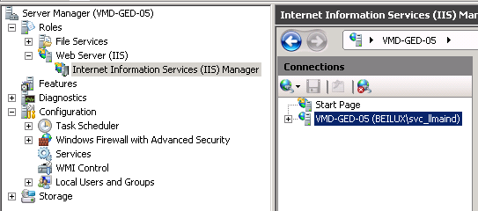
      - execute restart (rightmost console pane)
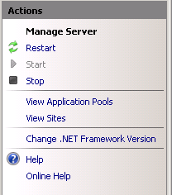
- Refresh the required EFS files
  - Go to the target system and map a drive to the path \\beilux.eib.org\v_disk\programs\EA_admin\OpenText\Tools\_Refresh\EFSRefresh-BatchCopyScriptsGeneration

Execute the script “refresh-input-file-generator-<last_version>.bat” having as parameter the target system (it can be one of VMD01|VMD03|UAT|IAT|VMP01|VMD05). Duration 45 min
E.g.: refresh-input-file-generator-2.3 UAT
Duration 45 min

This will generate 24 scripts on the source back end system, see below:

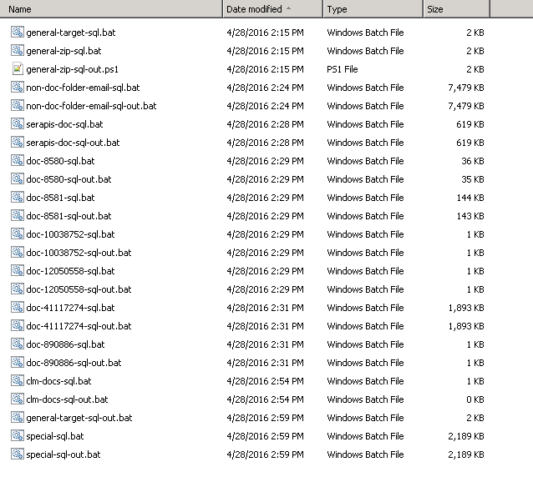

Action | Details
On the target backend system (UAT) map the network path pointing to the EFS copy generation scripts. | Check the Error: Reference source not found section for the location of the scripts.  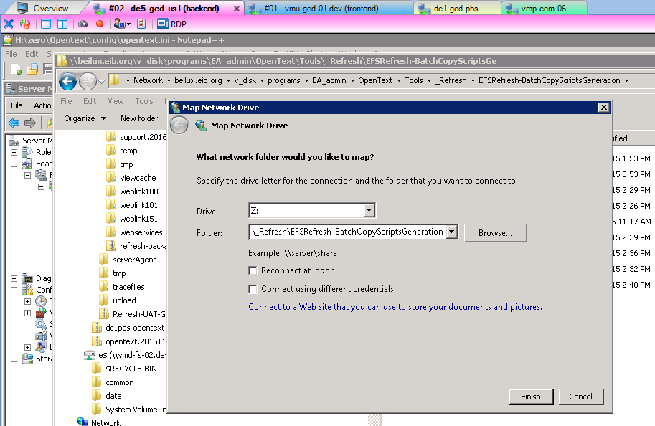
Execute the EFS copy scripts generation script from the target system (UAT). | 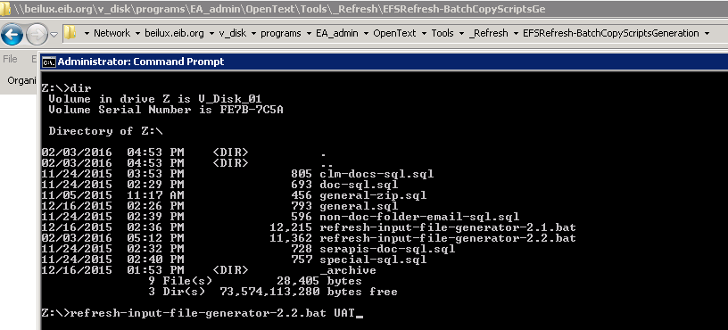  The script will create an input folder in the target system EFS base directory and store all generated EFS copy scripts there.  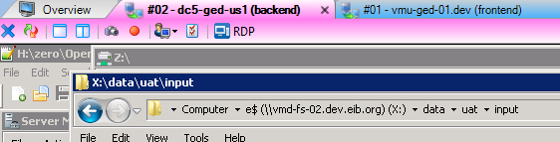
On the PROD backend system map the network path pointing to the EFS copy generated scripts. | 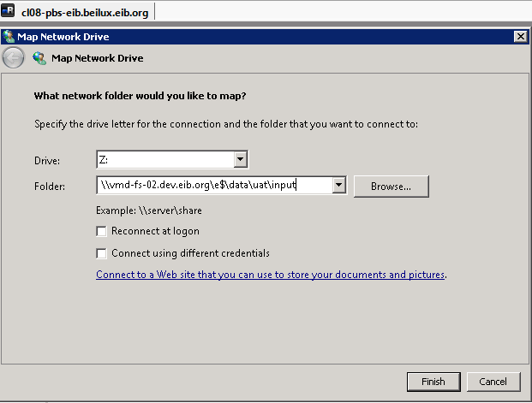
In the target system (UAT) clean the complete EFS folder structure from the base.  NOTE: DO NOT DELETE the input directory as this is the one holding the EFS copy scripts. | 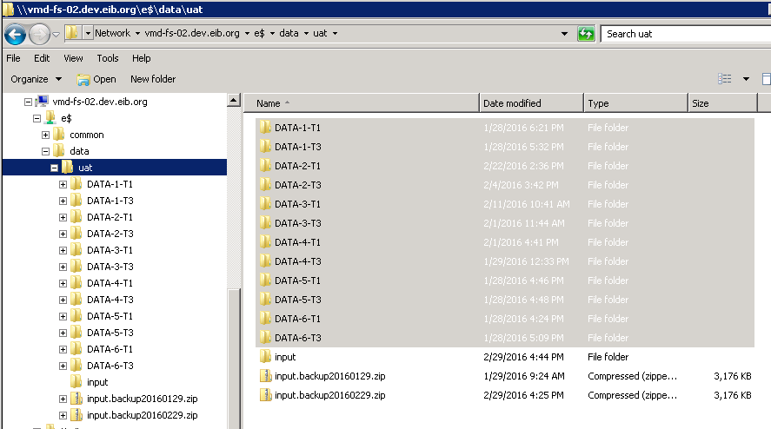
Once the EFS copy scripts generation is finished: use command prompt to go to the source system (PROD); go to the mapped drive; and execute the main script of the EFS copy procedure: general-target-sql-out.bat. | 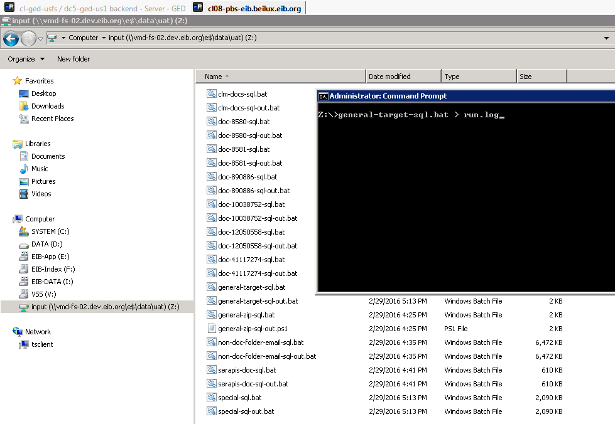  Note: the file “run.log” will contain details about the executed steps.

  - Go into the source system (which should have access to both source and target files base paths); open a CMD prompt and execute the script “general-target-sql-out.bat” with no parameters and using its UNC path (e.g. \\vmd-fs-01.beilux.eib.org\h$\data\input\general-target-sql-out.bat). This script was created by the previous script inside \input directory which, in turn, was created inside the target’s EFS files base path. This step will actually copy the pre-determined set of files into the target system.

- Procedural Steps – Anonymize
Action
-- #1 Anonymize all Personal Workspaces except GED IT Admins, Kofax and Admin
-- Create a temporary table as it will be faster to handle for all the queries.
CREATE TABLE TMP_DTREE_PWS_NAME AS (
SELECT dataid, name, 'Subtype_' || SUBTYPE || ', DATAID_' || DATAID newname FROM dtree
WHERE dataid in (
SELECT dataid FROM dbrowseancestors WHERE ancestorid IN (
SELECT id FROM kuaf WHERE type=0 and NAME NOT IN ('horkay_adm', 'fridael_adm', 'papamarg_adm', 'martinpe-adm', 'wong-adm', 'chassial_adm', 'kofax', 'Admin')
)
)
);
CREATE UNIQUE INDEX INDEX_TMP_DTREE_PWS_NAME ON TMP_DTREE_PWS_NAME (
DATAID
);
COMMIT;
-- #1.1 Rename all objects inside PWS
UPDATE DTree d
SET d.NAME = (
SELECT t.newname FROM TMP_DTREE_PWS_NAME t WHERE t.dataid = d.dataid
)
WHERE d.dataid IN (
SELECT dataid FROM TMP_DTREE_PWS_NAME
);
COMMIT;

-- #1.2 Rename all versions of objects inside PWSs
UPDATE DVERSDATA
SET FILENAME = 'Versionid_' || VERSIONID
WHERE docid IN (
SELECT dataid FROM TMP_DTREE_PWS_NAME
);
COMMIT;
-- #1.3 Rename all versions of objects with multilingual names (CS v10.0) inside PWs
UPDATE DTREEMULTILINGUAL w
SET w.NAME = (
SELECT t.newname FROM TMP_DTREE_PWS_NAME t WHERE t.dataid = w.dataid
)
WHERE w.dataid IN (
SELECT dataid FROM TMP_DTREE_PWS_NAME
);
COMMIT;

-- #1.4 Rename all versions of objects with pre-calculated names in a particular language (in this case EN and for CS v10.0) inside PWs
UPDATE WEBNODESMETA_EN L
SET L.NAME = (
SELECT t.newname FROM TMP_DTREE_PWS_NAME t where t.dataid = L.dataid
)
WHERE L.DATAID IN (
SELECT dataid FROM TMP_DTREE_PWS_NAME
);
COMMIT;
-- #2 Delete the temporary table for PWs and index
-- This statement could be skipped should we need to reset any changed names on request; other than that it is not needed
DROP TABLE TMP_DTREE_PWS_NAME;
COMMIT;
table TMP_DTREE_PWS_NAME dropped.
committed.
-- #3 Delete all e-mails
TRUNCATE TABLE otemailproperties;
TRUNCATE TABLE otemailparticipants;
TRUNCATE TABLE otemailbodies;
COMMIT;
-- #4 Anonymize certain areas below enterprise workspace
-- Create a temporary table as it will be faster to handle for all the queries.
-- WA
-- 07 Control: 891018
-- 08 Central Services: 890888
-- KnC
-- 07 Control: 890675
-- 08 Central Services: 891024
CREATE TABLE TMP_DTREE_NAME AS (
SELECT dataid, name, 'Subtype_' || SUBTYPE || ', DATAID_' || DATAID newname FROM dtree
CONNECT BY PRIOR dataid = ABS(parentid)
START WITH parentid IN (891018, 890888, 890675, 891024)
);
CREATE UNIQUE INDEX INDEX_TMP_DTREE_NAME ON TMP_DTREE_NAME (
DATAID
);
COMMIT;
-- #4.1 Rename all objects inside “07 Control” and “08 Central Services” (WA and KnC)
UPDATE DTREE d
SET d.NAME = (
SELECT t.newname FROM tmp_dtree_name t WHERE t.dataid = d.dataid
)
WHERE d.dataid IN (
SELECT dataid FROM tmp_dtree_name
);
COMMIT;
1,439,786 rows updated.
-- #4.2 Rename all versions of objects inside “07 Control” and “08 Central Services” (WA and KnC)
UPDATE DVERSDATA
SET FILENAME = 'Versionid_' || VERSIONID
WHERE docid IN (
SELECT dataid FROM tmp_dtree_name
);
COMMIT;
1,615,535 rows updated.
-- #4.3 Rename all versions of objects with multilingual names (CS v10.0) inside “07 Control” and “08 Central Services” (WA and KnC)
UPDATE DTREEMULTILINGUAL w
SET w.NAME = (
SELECT t.newname FROM tmp_dtree_name t WHERE t.dataid = w.dataid
)
WHERE w.dataid IN (
SELECT dataid FROM tmp_dtree_name
);
COMMIT;
1,439,786 rows updated.
-- #4.4 Rename all versions of objects with pre-calculated names in a particular language (in this case EN and for CS v10.0) inside “07 Control” and “08 Central Services” (WA and KnC)
UPDATE WEBNODESMETA_EN L
SET L.NAME = (
SELECT t.newname FROM tmp_dtree_name t WHERE t.dataid = L.dataid
)
WHERE L.DATAID IN (
SELECT dataid FROM tmp_dtree_name
);
COMMIT;
1,439,786 rows updated.

-- #5 Delete the temporary table and index
-- This statement could be skipped should we need to reset any changed names on request; other than that it is not needed
DROP TABLE TMP_DTREE_NAME;
COMMIT;
table TMP_DTREE_NAME dropped.
committed.

-- #6 Change eMail addresses of all users to “GED-Admin@eib.org” (except users: 'horkay', 'fridael', 'papamarg', 'martinpe', 'wongian', 'chassial', 'liarakis')
UPDATE KUAF
SET MAILADDRESS = 'GED-Admin@eib.org'
WHERE id IN (
SELECT id
FROM kuaf
WHERE
MAILADDRESS IS NOT NULL AND
TYPE = 0 AND
NAME NOT IN ('horkay', 'fridael', 'papamarg', 'martinpe', 'wongian', 'chassial', 'liarakis')
);
COMMIT;
4,711 rows updated.

- DB Data changes
  - Use dbRefresh.sql file and execute commands step by step.
(Appendix B dbRefresh.sql)
Location of statement:

\\beilux.eib.org\v_disk\programs\EA_admin\OpenText\Tools\_Refresh\DBRefresh-StatementsBase

Manually run each statement - or set of statements - from the Post DB Refresh and EFS Copy database update SQL script.  Confirm location in Error: Reference source not found.  IMPORTANT NOTE: test the EFS storage locations from a Windows Explorer perspective to be sure they are pointing to the right place and that the target system has access to it. | The statements were not manually run. They were executed from a CMD DOS prompt and hung.  Help from Oracle DBA team was requested and the subsequent statements were executed.

Refresh description

Database preparations

# | Description | Who | Time | Done
 | Before the Oracle database can be restored all ContentServer connections need to be stopped.  Use GED Service Tool to stop all ContentServer instances connected to that Database. | SAW
 | Create Remedy ticket requesting refresh of the database with a copy from PROD (CSPRD) (Add a specific date/time for the restore files if required)  Also request that the ‘llmainp’ database password be changed (This is a precaution against accidentally accessing the PROD system)  Confirm that ContentServer processes related to the database being refreshed are stopped.  Ticket data:  Entity: Platform Services  Application: Database  Module: ORACLE_  Item: <db-sid> (e.g. csuat2)  Phase: NON-PRODUCTION  Email: ORACLE-DBA, MUNRO John  (HANSEN Eric) | SAW

ContentServer 10.0 refresh
This chapter describes the steps that need to be taken to refresh the ContentServer file system.

Copy ContentServer files from PRODuction (CL08-PBS-EIB)
The instructions in this paragraph can be done whilst waiting for the database refresh.
A copy of the PROD <HOME> (opentext) files are required for the refresh.

# | Description | Who | Time | Done
 | Backup the ContentServer PROD system by using “Send to” – “Compressed (zipped) folder” to archive the folder:  Login to CL08-PBS-EIB as User beilux\svc_llmainp  locate the folder “E:\zero\Opentext”  Use “Send to” – “Compressed (zipped) folder” to create a zip file rename the zip file  PBS-EIB-opentext-<yyyymmdd-hhmm>.zip  cut and paste the zip file to “E:\common\transfer\” | SAW
 | Copy the zip file to the system to be refreshed.  Copy \\cl08-pbs-eib\e$\common\transfer\PBS-EIB-opentext-<yyyymmdd-hhmm>.zip  \\cl-ged-usfs\e$\installTransfer\ | SAW
 | Grab together all patches and modules, that are not installed on the backend, but on some of the front end machines. | SAW

Backup files on server to be refreshed
# | Description | Who | Time | Done
 | Backup the <HOME> (Opentext) folder of the ContentServer system to be refreshed. Use “Compressed (zipped) folder” to archive the folder:  Login to <server> as <user>  locate the folder “<drive>:\<instance>\Opentext”  Use “Send to” – “Compressed (zipped) folder” to create a zip file  and rename the zip file to “<server>-Opentext-<yyyymmdd-hhmm>.zip”  In <HOME> rename subfolder “config”, “module”, “patch” and “support” to <name>_bkp_<yyyymmhh> | SAW

Refresh JBoss WAR files
# | Description | Who | Time | Done
 | Backup the JBoss WAR files from server to be refreshed.  Locate directory “<drive>:\<instance>\jboss\server\web\deploy”.  Use “Sent to zip file”.  Rename zip file to <deploy>.<yyyymmdd-hhmm>.zip | SAW
 | Copy the JBoss WAR files from PRODuction (CL08-PBS-EIB) to server to be refreshed.  copy “E:\zero\jboss\server\web\deploy\*.war” to  “<drive>:\<instance>\jboss\server\web\deploy\*.war”. | SAW

Refresh files
It is assumed the ContentServer processes have been stopped (see 3.2 #1)

# | Description | Who | Time | Done
 | Unzip PROD backup file “PBS-EIB-opentext-<yyyymmdd-hhmm>.zip” from PRODuction (CL08-PBS-EIB) to server to be refreshed  “<drive>:\<instance>\Opentext”  (will overwrite <HOME> (opentext) directory of server to be refreshed) | SAW

Changes in opentext.ini – correct all entries linked to PRODuction
(correct ports / pathes / urls …) (to be reviewed)
# | Description | Who | Time | Done
0. | Consult old opentext.ini for entries and values to be change manually.
1. | In section [general] change following parameters:  [general]  …  Server=<system>.lux.eib.org  dftConnection=<displayuser>  UploadDirectory=/global/<system>/livelink/llmain/tmp/  LBIPs={'<LBIP-ID>'}  ….  *system: virtual hostname of ll-server  *displayuser: llmaind, llmaini, llmainu, llmaint and llmainc | SAW
2. | In section [security] change following parameters:  [security]  …  CGIHosts=::ffff:<webservers ip address>, …  cookieKey=CBC/global/<system-work-data-path>/data  … | SAW
3. | In section [DirectoryService:LDAP] change the parameters  [DirectoryService:LDAP]  …  password=hidden  serverPort=389  serverName=ldapcorp-test.lux.eib.org  llServername=  … | SAW
4. | Since LL Explorer 4.8.2 has problems and won’t let you set up a DB connection, if none is there, we’ve to copy the connectionparameters manual from the previous servers opentext.ini.  …  [general]  …  dftConnection=<displayuser>  …  [dbconnection:<displayuser>]  encrypteduserpwd=<from old opentext.ini>  username=<from old opentext.ini>  servname=<from old opentext.ini>  servtype=ORACLE  …  *displayuser: see 3.3.3.1 (1.) | SAW
5. | In section [JavaModulesConfig] change following parameters:  [JavaModulesConfig]  …  rmiPort=1099  … | SAW
6. | In section [SearchOptions] change following parameters:  [SearchOptions]  …  truncation=165  pathtruncation=200  … | SAW
7. | In section [DCSServers] delete all wrong admin-server entries | SAW
8. | In section [esign] set correct VersionDirsPath  [esign]  …  VersionDirs_x_x=<DirsPath>  … | SAW
9. | In section [permviewer] change following parameters:  [permviewer]  …  tempDir=/global/<system-work-data-path>/data/upload  … | SAW
10. | In section [Weblink] change following parameters:  [Weblink]  …  port=<from old opentext.ini>  … | SAW
11. | In section [Explorer] change following parameters:  ! Only ON PROD = FALSE !  [Explorer]  …  SavePasswordLocally=TRUE  … | SAW
12. | Set the Upload Path on “?func=admin.sysvars” and make sure the user running the webserver and the user running the ContentServer server have got read and write access to that directory. | SAW

WebDAV path correction:
goto: …\opentext\weblink151\inst\webdav_Livelink\iisvdir_x64
open: weblink_isapi.ini
set: server=file:<othome-path>/weblink151/portfile
If done, restart the WebServer on Content Server server …
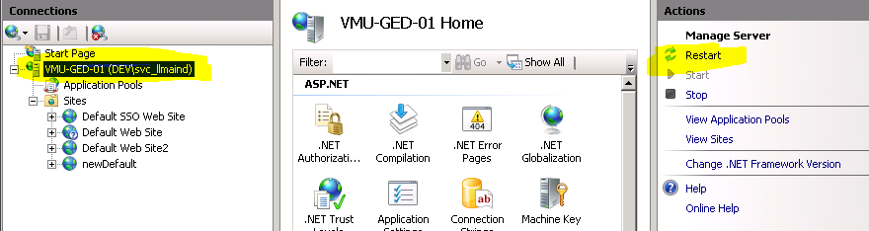

Database Data Changes
see APPENDIX B for instructions
(sqlRefresh.sql)

# | Description | Who | Time | Done
1. | Check "Livelink.LogicalProviders" entries in KINI!  select * from kini  where inisection='Livelink.DocStorage'  or inisection='Livelink.LogicalProviders'  Correct the inivalue column, if not set proper.  Livelink.DocStorage → Default  {'ExtShared','\\\\<system-efs-path>\\DATA-1-T1\\'}  Livelink.LogicalProviders → Default  {'ExtShared','\\\\<system-efs-path>\\DATA-1-T1\\'}  Livelink.LogicalProviders → MVPVolumne10  {'ExtShared','\\\\<system-efs-path>\\DATA-1-T1\\'}  Livelink.LogicalProviders → MVPVolumne11  {'ExtShared','\\\\<system-efs-path>\\DATA-2-T1\\'}  Livelink.LogicalProviders → MVPVolumne12  {'ExtShared','\\\\<system-efs-path>\\DATA-3-T1\\'}  Livelink.LogicalProviders → MVPVolumne13  {'ExtShared','\\\\<system-efs-path>\\DATA-4-T1\\'}  Livelink.LogicalProviders → MVPVolumne14  {'ExtShared','\\\\<system-efs-path>\\DATA-5-T1\\'}  Livelink.LogicalProviders → MVPVolumne15  {'ExtShared','\\\\<system-efs-path>\\DATA-6-T1\\'}  Livelink.LogicalProviders → MVPVolumne20  {'ExtShared','\\\\<system-efs-path>\\DATA-1-T3\\'}  Livelink.LogicalProviders → MVPVolumne21  {'ExtShared','\\\\<system-efs-path>\\DATA-2-T3\\'}  Livelink.LogicalProviders → MVPVolumne22  {'ExtShared','\\\\<system-efs-path>\\DATA-3-T3\\'}  Livelink.LogicalProviders → MVPVolumne23  {'ExtShared','\\\\<system-efs-path>\\DATA-4-T3\\'}  Livelink.LogicalProviders → MVPVolumne24  {'ExtShared','\\\\<system-efs-path>\\DATA-5-T3\\'} | SAW

Refresh the required EFS files (manual)
see APPENDIX C.4 for instructions
(efsRefresh.sql)

# | Description | Who | Time | Done
1. | Create xcopy batch files from efsRefresh.sql  - non-docs  - all docs  - serapis WA docs  - CLM docs (only if required) | SAW
2. | Map network drives needed to run the batch files | SAW
3. | Correct the source and target path in the batch files
4. | Run the batchfiles

Refresh the required EFS files (automated - to be reviewed)
see APPENDIX C for instructions
The refresh the EFS files requires the running of three scripts: refesh_input_file_generator, refresh_tar_file_generator and refresh_untar. The scripts rely on a standard set of folders and file names being used, although the user does have the option of using different folders should they wish.
Each of the servers to be refreshed - UAT (fennel), DEV (gento), IAT (kielder) and TRAINING (mint) have had the required folders created. The working folder in each case is
/global/<server>/livelink/<user>/efs_copy_files/

Refresh_input_file_generator_<version>.bash (to be reviewed)
This script is used to create a list of .in files used by the refresh_tar_file_generator script.
This file needs to be run against the restored database in §3.2. If the script is run against, for example, the PRODuction database then there is a possibility of some of the objects being incorrect and this could cause unexpected problem in the future.
Note the file will only create a standard 'agreed' list of EFS files, they are:
GedOid | GedName
NONDOC | Non Documents, Folder and email objects
8580 | GED Support Centre
8581 | Document Templates
10038752 | Search Templates
104502 | System Files
By SQL | All Serapis Documents from WA (all versions) – NON ALLOC*
By SQL | All CLM Documents from KC (starting date >= 2014-06-01)

APPEARANCES
(manual copy from PROD → add version to target with differ color and description to identify immediately test system / PROD!)
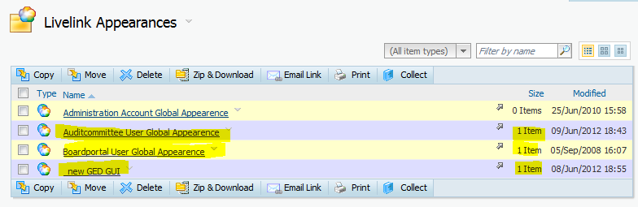

Refresh_tar_file_generator_<version>.bash (to be reviewed)
This script should be run on dc1-ged-pbs (/global/dc1-ged-pbs/livelink/llmain/efs_copy_files)
The script will create a set .tar or .tar.gz files in subpath "efs_tar_gz_files" and rename all files in subpath "input_files". These files ("efs_tar_gz_files/*.*" and "input_files/*.*" will then be copied (scp) to the relevant server being refreshed path (/global/<server>/livelink/llmain/efs_copy_files/efs_tar_gz_files).

Refresh_untar_<version>.bash (to be reviewed)
This script is used to untar the resulting .tar or .tar.gz files from the refresh_tar_file_generator script. The script must be run on the server being refreshed.

Post installation tasks
The following steps need to be taken before the system can be used.

Clean up of folders - if required
# | Description | Who | Time | Done
1. | If exists, remove all directories and files from the llhome/staging folder | SAW

Start ContentServer Services
# | Description | Who | T  i  m  e | D  o  n  e
1. | Start ContentServer Services | S  A  W

Setup DB connection (Already done in 3.3.3.1 (4.))
# | Description | Who | Time | Done
 | Start ContentServer services | SAW
 | Using a browser connect to the refreshed ContentServer system admin pages -  http://<server>.beilux.eib.org/ged/ged.dll?  func=admin.index  Select Existing database | SAW
 | The following should be available from the DBA.  Type in Oracle Username  Type in password  Type in service name | SAW
 | You will now be prompted to log into the refreshed system as 'Admin'.  Note, the password is same one as used on PRODuction - if you do not know the password, find somebody who does to login for you and also to carry out the next step - §3.4.3 Change Admin User Password | SAW

Change passwords (Admin, Interface-Account and set special User-Rights)
# | Description | Who | Time | Done
 | Login as “Admin” and go to  http://<server>.lux.eib.org/livelink/livelink?func=personal.settings | SAW
 | Select 'Password' tab | SAW
 | Put in 'old' and 'new' passwords where indicated  select Update | SAW
 | Should get "Your password has been updated successfully"  select 'OK' | SAW
 | Change password for interface-users:  - update kuaf set USERPWD = 's5V.FRto9pF9U.OEyhSFj' where id = 102371; --,'serapis'  - update kuaf set USERPWD = 'c7P3rALZ9u6wub165b/jZ' where id = 102372; --,'mercator'  - update kuaf set USERPWD = 'y5MYOYZsIafqFKVhRheHf' where id = 392366; --,'kofax'  - update kuaf set USERPWD = 'g5m7hP6a9Fz8UbdGA./x7' where id = 33373897; --,'forceprets'  - update kuaf set USERPWD = 'm69MJtK1Pd32hIs1NIyC6' where id = 36952019; --,'picged'  - update kuaf set USERPWD = 'e84oQ9zMkcaRtr36cKtox' where id = 39970845; --,'psft'  - update kuaf set USERPWD = '2lBJ.9daTLoKSQtIVPhJr' where id = 41480248; --,'lms'  - update kuaf set USERPWD = 'w7AqVtObTLslfsdJNRyDB' where id = 43560406; --,'sharepoint' former on nonprod 'sp-lladmin'  - update kuaf set USERPWD = 'm2dJN8erM5beGJIicq2iP' where id = 43566367; --,'trema'  - update kuaf set USERPWD = 'k4hIA8f7JprrZaiqo/n1/' where id = 51378964; -- user lending  - update kuaf set USERPWD = '5hmVdgLz3poOWSaWUxBgc' where id = 49634653; -- user clm  - update kuaf set USERPWD = '8xjzQZQ/l5jaxMOQhodoA' where id = 45737089; -- user gamma  - update kuaf set USERPWD = '4j//YJ2sZNRBFbRn/ZIE5' where id = 59573172; -- user pjcms  - update kuaf set USERPWD = 'c2cNyssIgbumWghN07Eb2' where id = 59552414; -- user swift  - update kuaf set USERPWD = 'm1LoAG6/fyvfL3djQGXmU' where id = 59464883; -- userPSFTretiree  - -- user svc_spadmin  (does not exist in GED PROD) PSW: “svc_spadmin”  - -- user svc_tst_webportal  (does not exist in GED PROD, but same rights as svc_webportal)  PSW: “Password01”  For the password consult PSW-Safe. | SAW
 | Set Useradmin rights for System-Admins (paukert-adm and wohner-adm) | SAW

Change SerapisGEDXML configuration
# | Description | Who | Time | Done
 | ?func=serapisgedxml.configureserapisged  Check the DTD file shows correct version  Check that the version of the merge service is compatible with the refreshed version of Serapisgedxml | SAW
 | Make sure the 'Log Debug output to Thread/Merge Service logging" is unchecked, respective the level is set to 0  Failure to do this step could lead to the thread logs growing very quickly to the 2GB limit (under one hour) should a large message be submitted by 'mercator' | SAW
 | In the Message Active Setting area - change the:  Request XML Archive Path  Success XML Archive Path  Warn XML Archive Path  Error XML Archive Path  To  <log-dir-path-interfaces>/common/serapisgedlogs | SAW
 | In the Message Active Setting area - change the “Notification Request Archive Path” to  <log-dir-path-interfaces>/common/serapisgednotifications | SAW
 | In the Merge Processing Settings, change the Server IP address to the one indicated in the ContentServer Info Matrix document.  Note: Check that the version of the Merge service is compatible with the version of the Serapisgedxml module installed as part of this system refresh. If the wrong version of the merge service is installed arrange for the correct version to be installed. | SAW
* <sys-data-path>: DEV: /global/livelink/data/dev/
IAT: /global/bled/data/
UAT: /global/livelink/data/uat/
TRG: /global/livelink/data/training/

Change ForcePrets configuration
# | Description | Who | Time | Done
 | ?func=forcepretsgedinterfaceadmin.generalsettings  In the logs area - change the Logs Path to  <log-dir-path-interfaces>/common/forcepretslogs | SAW

Change Sharepoint Documents GED Interface configuration
# | Description | Who | Time | Done
 | ?func=spdocsgedinterfaceadmin.generalsettings  In the logs area - change the Logs Path to  <log-dir-path-interfaces>/common/spdocsgedlogs | SAW

Change Pic configuration
# | Description | Who | Time | Done
 | ?func=saweibpictiersinterface.generalsettings  In the logs area - change the “Logs Path” to  <log-dir-path-interfaces>/common/pictierslogs | SAW

Change MultiFileOutput configuration
# | Description | Who | Time | Done
 | ?func=multifile.settings  In the temporary directory settings - change the “Temporary Directory” to  <log-dir-path-interfaces>/common/multifile | SAW

Change MultiAgent configuration
# | Description | Who | Time | Done
 | ?func=saweibmultiagent.generalsettings  In the Log Settings - change the “Log Directory” to  <log-dir-path-interfaces>/common/multiagent | SAW
?func=saweibmultiagent.generalsettings
In the EAI Define Document - change the “EAI define document server adress and path” to
http://<eai-server>:8180/
WebserviceFacade/InvoiceManagement
* <eai-server>: DEV: vmd-integra-01
IAT: vmt-integra-01
UAT: vmu-integra-01
TRG:
?func=saweibmultiagent.generalsettings&agentId=220248
In the Log Settings – change the “Log Directory” to
<log-dir-path-interfaces>/common/multiagent
?func=saweibmultiagent.generalsettings&agentId=220248
In the Process Settings – change the “Root directory to store temporary exported files” to
<log-dir-path-interfaces>/common/multiagent
?func=saweibmultiagent.generalsettings&agentId=220248
In the Publish/Upload Document – change the “publish document server address and path to
http://cms2.lux.eib.org/registry2web/services/ImportControler

Change SPDocsGedInterface configuration
# | Description | Who | Time | Done
 | ?func=spdocsgedinterfaceadmin.generalsettings  In the Log Settings - change the “Log Directory” to  <log-dir-path-interfaces>/common/spdocsgedlogs | SAW

Change DFT connection string (Already done in 3.3.3.1 (4.))
# | Description | Who | Time | Done
 | This is a non PRODuction system, so the dftconnection string in the opentext.ini file needs to be changed. The DFTconnection is used as part of the cookie and if incorrect will affect Serapis Users. The PROD environment uses llmainp. For other systems use:  DEV - llmaind  IAT - llmaini  UAT - llmainu  TRAINING - llmaint | SAW
 | Copy  opentext.ini  to  opentext.ini.<server>.yyyymmdd-hhmm | SAW
 | Open the opentext.ini file for editing (in VI or through WinSCP) | SAW
 | Edit the line:  dftconnection=<user>  Change <user> to value indicated above | SAW
 | Edit the block:  [dbconnection:<user>]  Change <user> to the same value as in the previous action. | SAW
 | Save the opentext.ini file | SAW
 | restart ContentServer processes to confirm changes are OK | SAW

Update database connection for Webform database lookup
# | Description | Who | Time | Done
 | ?func=ll&objType=236&objAction=browse  Edit the connection “csprd”, change password and db service name | SAW

Anonymize database
# | Description | Who | Time | Done
 | Execute the SQL statements listed in to change the object names inside personal workspaces and remove some email objects.  See Appendix C-4 | SAW

On UAT and DEV Create backup Admin server
On the UAT and DEV environments create a backup Admin server to allow for the refresh of the relevant front-end server.

# | Description | Who | Time | Done
 | Stop services
 | Backup the database on disk via rmandisk | Oracle
 | Clean up the /global/<server>/livelink/<user>/ folder (remove old backups, core files, other old folders) | SAW
 | Backup the ContentServer system to llhome.<server>.yyyymmdd-hhmm.tar by using  tar cvf <filename> /global/<server>/livelink/<user>/llhome/ to archive the llhome folder. | SAW
 | Gzip the resulting tar file  gzip llhome.<server>.yyyymmdd-hhmm.tar file | SAW
 | Copy the llhome.<server>.yyyymmdd-hhmm.tar.gz file to /global/<server>/livelink/<user>/ on the first front-end | SAW

Create 1st ContentServer Front-end (UAT and DEV only)

Create 1st ContentServer Front-end
# | Description | Who | Time | Done
 | Rename  /global/<system>/livelink/<user>/llhome  to  /global/<system>/livelink/<user>/llhome_yyyymmdd-hhmm | SAW
 | Gunzip the  llhome.<server>.yyyymmdd-hhmm.tar.gz | SAW
 | Untar the file:  llhome.<server>.yyyymmdd-hhmm.tar | SAW
 | Remove the file:  llhome.<server>.yyyymmdd-hhmm.tar | SAW
 | DO THE NEXT STEP, Chris Alman’s run_ini script, IMMEDIATELY, otherwise a browser calling  http://<server>/livelink/livelink  will point to PRODUCTION  PATH: /global/<system-work-path>/transfer/tools/llcopy/ | SAW

Run Chris's script - See Appendix A

Run Chris's script - See Appendix A

Restart ContentServer
# | Description | Who | Time | Done
 | Verify that the connect logs are switched off (wantLogs=FALSE)  or deselect 'Log Selections' from the  http://<server>.lux.eib.org/livelink/livelink?func=systemobj.ini  page | SAW
 | Start services | SAW
 | Go to the Administration page
4. | The select database screen is shown…
5. | Select the ‘Select existing database option’
6. | Click on ‘Continue’  (as there is only one RDBMS type available)
7. | Enter Oracle User name: <Oracle_name>
8. | Enter Oracle password: <Oracle_password>
9. | Enter Oracle service name: <Oracle_system>
10. | Click on continue
11. | Enter the Admin password and press log-in
12. | Verify basic functionality

Enable Load Balancer
# | Description | Who | Time | Done
 | Enable Load Balacer | IT
 | INSTRUCTIONS based on how we disabled load balancer | SAW

Create Indexes
The procedure to create the indexes is more detailed than just creating the indexes from the index menu. Please make sure all of the following steps are performed!

Clean Index Files
Action | Details
Clean the Index folder structure of the target system (UAT) backend.  Confirm location in Error: Reference source not found. | 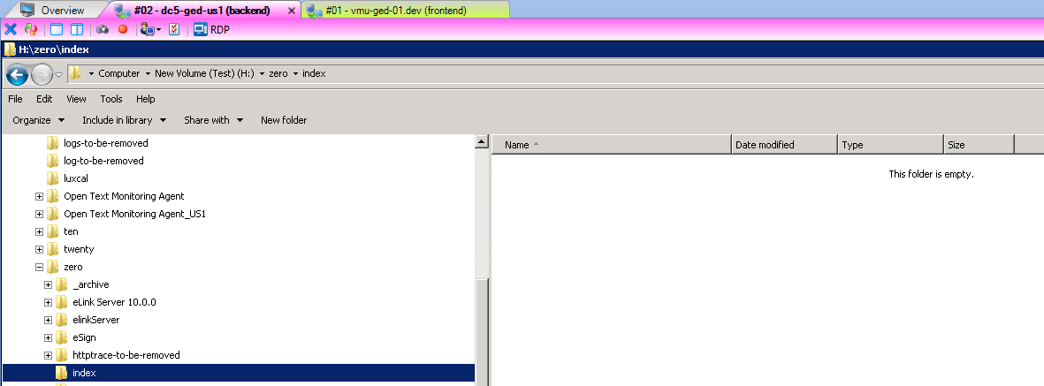
Remove search.ini, otadmin.cfg, otadmin.pid and the otadmin folder in OT HOME:  - Backend;  - Frontend. | Backend:  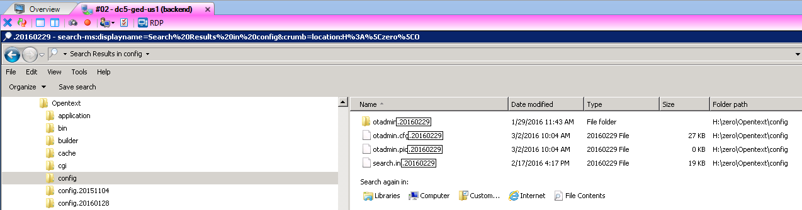  Frontend:  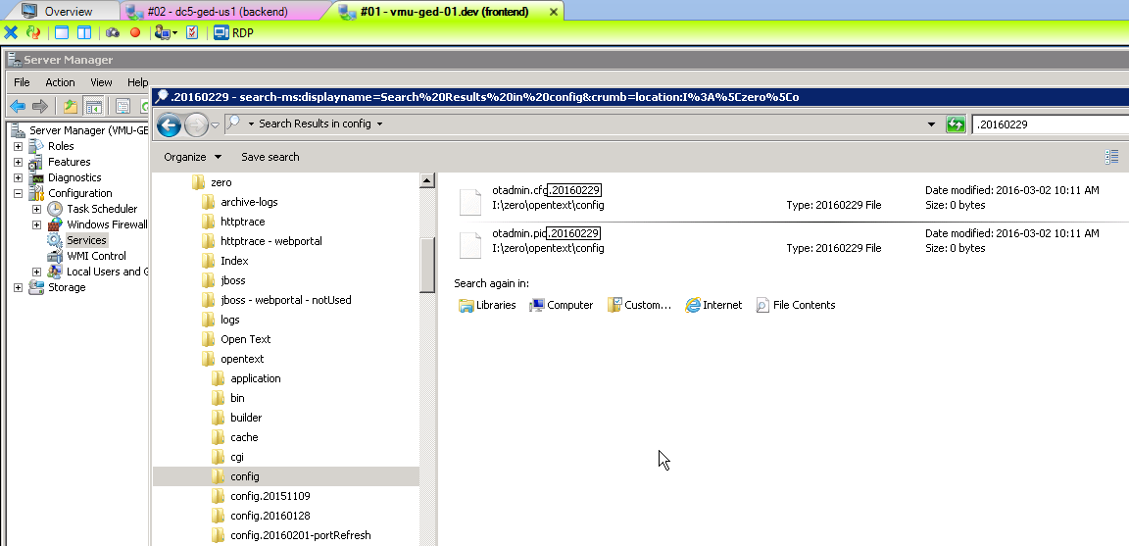

Change Storage Provider Settings - Configure Storage Rules
This step should not be required as the scripts should set disk free figures which mean all volumes should be writeable.
# | Description | Who | Time | Done
 | Go to Admin Index page | SAW
 | Select 'Storage Provider Settings' | SAW
 | Configure Storage Rules http://<server>?func=storageprovider.rules | SAW
 | Make sure that for every volume in the 'Old Volume / Minimum Free Space / Actual Free Space' column, the 'Minimum Free Space' figures are SMALLER than the 'Actual Free Space' figures. If any are not, then either make space or change the 'Minimum Free Space' entries, then hit 'Save Changes' | SAW
 | Restart ContentServer services on <admin_server> | SAW

Create New Index and dataflow
Create and configure search (setup the default server settings). Only backend of the target landscape (UAT). | Configure General, File Cache and DCS.  Backend:  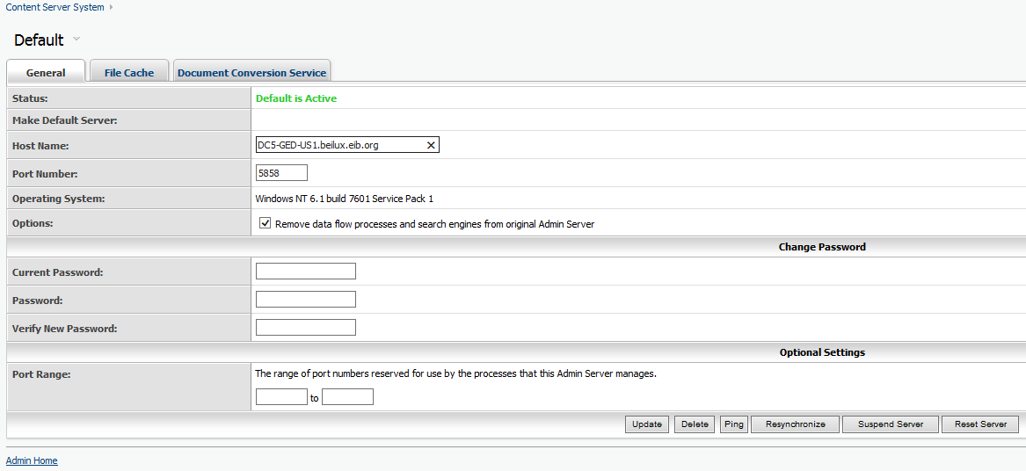  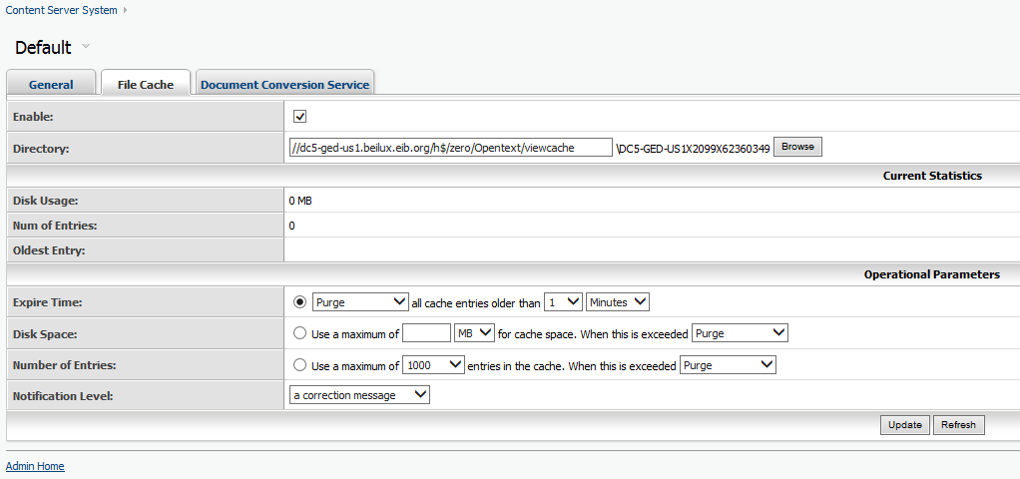  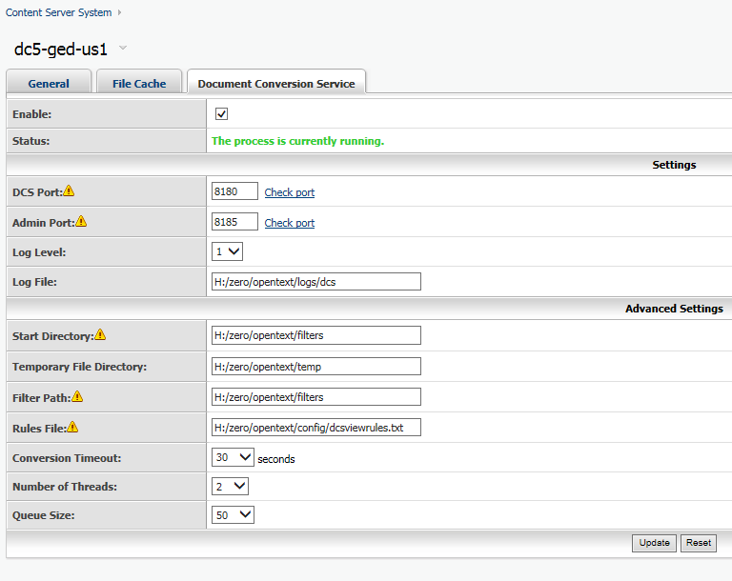
Create Search Indexes. Backend only. | Admin Help Data Source  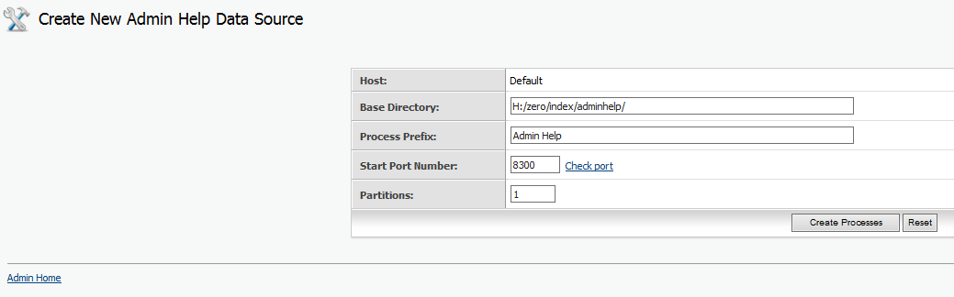  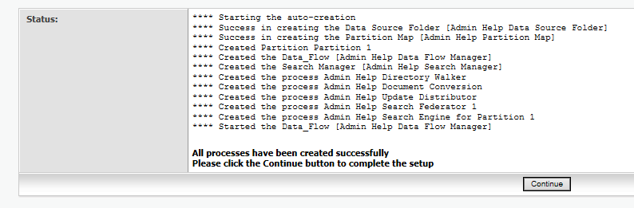  User Help Data Source  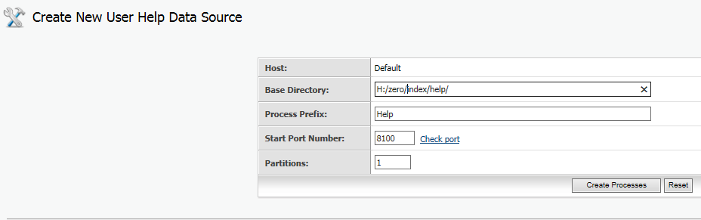  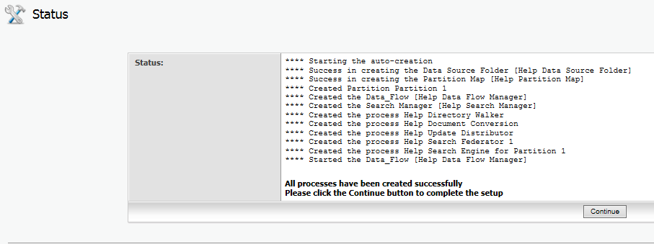  Enterprise Data Source  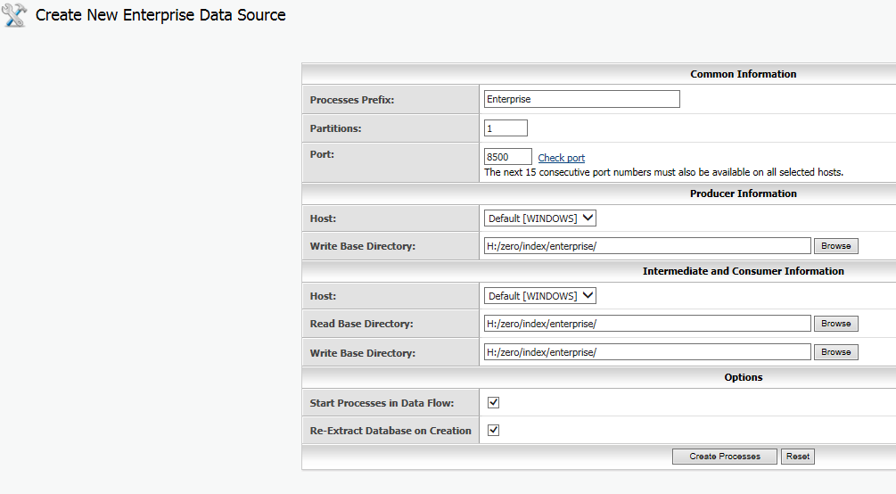  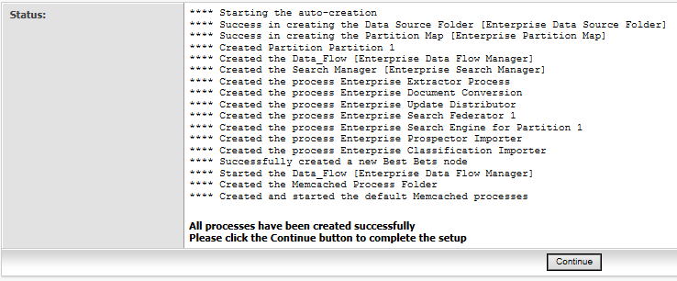
Replace system-dependent appearance in the target system (UAT). | Go to the production system to get the correct UAT appearance. Located at https://gedadmin.beilux.eib.org/ged/ged.dll/open/60980351  Download Header-UAT.html to a local directory.  Go to Livelink Appearances in the target system (UAT).  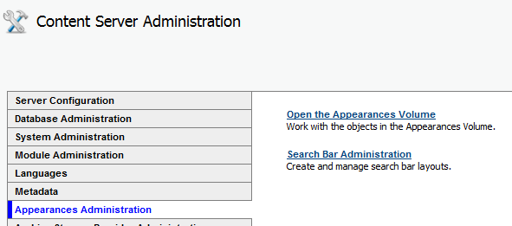  The downloaded “Header-UAT.html” has to be added as version to content “Header” of appearance “_new GED GUI” in the target system (UAT).  Click on _new GED GUI.  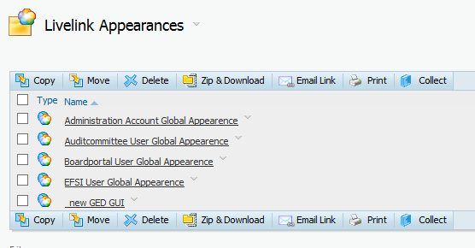  Go to Workspace (bottom of the page) and click on “Layout Content”.  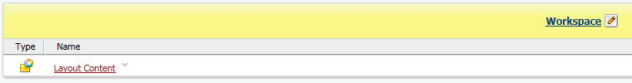  “Add Version” to the Header object.  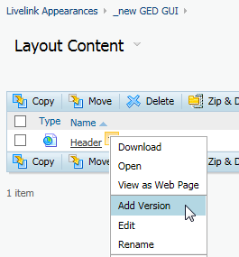  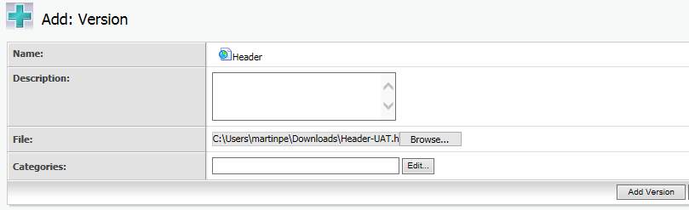  Add version.

Create indexes
Before creating the indexes verify that all entries are deleted (you cannot create any new otherwise ☺ ) and check if the directories of the index (help → Help Data Source Folder, adminhelp → Admin Help Data Source Folder, enterprise → Enterprise Data Source Folder) are successfully deleted or renamed on the hard disk at /global/<server>/livelink/llmain/index/

# | Description | Who | Time | Done
 | Go to the Administration page and select the System Object Volume | SAW
 | If exists, delete Object "Admin Help Data Source Folder" | SAW
 | If exists, delete Object "Help Data Source Folder" | SAW
 | If exists, delete Object "Enterprise Data Source Folder" | SAW
 | Check path "/global/<server>/livelink/llmain/index/help",  if exists, delete or rename … | SAW
 | Check path "/global/<server>/livelink/llmain/index/adminhelp",  if exists, delete or rename … | SAW
 | Check path "/global/<server>/livelink/llmain/index/enterprise",  if exists, delete or rename … | SAW

Enterprise index
# | Description | Who | Time | Done
 | Go to the Administration page and select the View System Object Status option | SAW
 | Click the Purge History button | SAW
 | Confirm the purge | SAW
 | The log of the System Alert messages is now cleared…
 | Press Ok | SAW
 | Return to the Administration page and select the View System Object Status option again | SAW
 | Click the Test button | SAW
 | Review the errors (if any) | SAW
 | Click Ok | SAW
 | Go to the Administration page and select the Open the System Object Volume option | SAW
 | Verify the Admin server status is ‘Active’ | SAW
 | Select Add new item | SAW
 | Select Enterprise Data Source | SAW
 | This brings up the Create New Enterprise Data Source screen…
 | Leave Process prefix set to Enterprise | SAW
 | Set number of partitions  For DEV, IAT and TRAINING set number of partitions to 1  For UAT set the number of partitions to 6 | SAW
 | Set Port number to <llindex_port> | SAW
 | Leave Host set to Default [Unix] | SAW
 | Set Write base directory to:  /global/<server>/livelink/llmain/index/enterprise | SAW
 | Leave Host set to Default [Unix] | SAW
 | Set Read base directory to: /global/<server>/livelink/llmain/index/enterprise | SAW
 | Set Write base directory to: /global/<server>/livelink/llmain/index/enterprise | SAW
 | Start processes in data flow option should be unselected | SAW
 | Reindex documents option should be unselected. | SAW
 | Click on Create Processes button. (Timed out after 15 minutes, but was finished in 30 minutes - check status with following command:  Only if there is no Livelink Monitoring Agent  http://<server>?func=admin.threadstatus) | SAW
 | Processes and folders are now created…
 | Open the System Object Volume, Enterprise Data Source Folder, Enterprise Data Flow Manager | SAW
 | Enterprise Extractor Process, Click on function menu, Start | SAW
 | Set refresh to 1 minute | SAW
 | Check for #messages in 'Pending' column of 'Interchange Pools' | SAW
 | Enterprise Document Conversion, Click on function menu, Start | SAW
 | Check for #messages in 'Pending' column of 'Interchange Pools' | SAW
 | Enterprise Update Distributor, Click on function menu, Start | SAW
 | Check for #messages in 'Pending' column of 'Interchange Pools' | SAW
 | Do test search | SAW
 | Because we need only test-search not an exact copy → after a while of indexing  Stop Extractor Process | SAW
 | Set 'LastUpdateLibraryNode' to -1 stops further extracting of old documents. This value is set in ExtendedData of Object "Enterprise Extractor Process".  Get DATAID of Object "Enterprise Extractor Process" and modify Datafield "ExtendedData" of Object in Table DTREE. | SAW
 | Start Extractor Process | SAW

User Help index
# | Description | Who | Time | Done
 | Go to the Administration page and select the Open the System Object Volume option | SAW
 | Verify the Admin server status is ‘Active’ | SAW
 | Select Add new item | SAW
 | Select User Help Data Source | SAW
 | This brings up the Create New User Help Data Source screen…
 | Leave Process prefix set to Help | SAW
 | Set Base directory to: /global/<system>/livelink/<user>/index/help/ | SAW
 | Leave Host set to Default [Unix] | SAW
 | Set partition = 1 | SAW
 | Click on Create Processes button | SAW
 | Processes and folders are now created…
 | Do test search | SAW

Admin Help index
# | Description | Who |  | Time |  | Done
 | Go to the Administration page and select the Open the System Object Volume option |  | SAW
 | Verify the Admin server status is ‘Active’ |  | SAW
 | Select Add new item |  | SAW
 | Select Admin Help Data Source
 | This brings up the Create New Admin Help Data Source screen… |  | SAW
 | Leave Process prefix set to Admin Help |  | SAW
 | Set Write base directory to: /global/<system>/livelink/<user>/index/adminhelp/ |  | SAW
 | Leave Host set to Default [Unix] |  | SAW
 | Set partition = 1 |  | SAW
 | Click on Create Processes button |  | SAW
 | Processes and folders are now created…
 | Do test search |  | SAW

Creating Admin server entries
# | Description | Who | Time | Done
 | Go to the Administration page and select the Browse system object volume option | SAW
 | Select Add Admin server | SAW
 | Add every front-end as Admin server, making sure to use the correct port numbers (consult ContentServer Info Matrix) | SAW
 | Verify after creation that all Admin servers are running with the name of the instance and NOT the name of the hardware. | SAW

Enable Notifications
# | Description | Who | Time | Done
 | Go to the Administration page and select the Configure Notifications option | SAW
 | Click the Enable Notifications button | SAW
 | Restart services | SAW
 | Verify on all front-end servers that EnableNotifications=TRUE and EnableAgents=TRUE in the opentext.ini | SAW
 | Restart services on all front-end servers | SAW
 | Verify notifications being created | SAW

Create/update Slices
# | Description | Who | Time | Done
 | Go to the Administration pages | SAW
 | Select the Reset Search template option | SAW
 | Reset search template | SAW
 | Go to the Administration pages | SAW
 | Go to the System Object Volume | SAW
 | Go to the Slice Folder | SAW
 | Remove “All Workspaces” and “All Workspaces [All Versions]” | SAW
 | Rename “Enterprise” and “Enterprise [All Versions]” to “All Workspaces” and “All Workspaces [All Versions]”
 | Any existing slice needs to be updated to verify the correct search manager is attached. This can be done from the function menu -> Specific. Verify the search manager is set and press update.  probably the shortest way is to delete them and create new. | SAW
 | Verify each search slice | SAW

Cluster Control (UAT only) (NEEDS WORK)

Cluster operation and monitoring tests
# | Description | Who | Time | Done
 | Backup database on tape. (40mins) | Oracle
 | Remove UNDO02 / Set UNDO01 online. (5mins) | Oracle
 | Stop database . (5mins) | Oracle
 | Umount ORA_east_data FS (5mins) | Oracle
 | Mount ORA_east_data1 FS on /global/east/data (5mins) | Oracle
 | Restart LLGED2. (5mins) | Oracle
 | Restart under cluster control (5mins) | Unix
 | Review cluster status and logs (5mins) | Unix

Cluster operation and monitoring tests
# | Description | Who | Time | Done
 | Stop all ContentServer applications with operator menu (5mins) | Ops / Unix
 | Check the monitoring (10 mins) | Ops / Unix
 | Start all ContentServer applications with operator menu (5mins) | Ops / Unix
 | check the applications (10 mins) | Ops / Unix
 | Check the monitoring (10 mins) | Ops / Unix
 | Power off dogsby (10 mins) | Ops / Unix
 | Check all ContentServer applications (10 mins) | Ops / Unix
 | Check the monitoring (10 mins) | Ops / Unix
 | Power off doodles (10 mins) | Ops / Unix
 | Check the monitoring (10 mins) | Ops / Unix
 | Restart doodles (10 mins) | Ops / Unix
 | Check all ContentServer applications (10 mins) | Ops / Unix
 | Check the monitoring (10 mins) | Ops / Unix
 | Restart dogsby (10 mins) | Ops / Unix
 | Stop all ContentServer applications with operator menu | Ops / Unix
 | Start all ContentServer applications with operator menu (10 mins) | Ops / Unix
 | Check all ContentServer applications (10 mins) | Ops / Unix
 | Check the monitoring (10 mins) | Ops / Unix
 | Check if backups can be launched OK | Ops / Unix
 | Check autosys | Ops / Unix
 | Stop ContentServer service 3x (cluster should restart services and after third time should switch to other node) | SAW
 | Verify if ContentServer server can be reached through browser | SAW

Start and test Kofax
# | Description | Who | Time | Done
 | To be detailed… | SAW

Start and test Mercator
# | Description | Who | Time | Done
 | To be detailed… | SAW

Verify system
# | Description | Who | Time | Done
 | Verify working of notifications - Needs more detail | SAW
 | Verify index creation - Needs more detail | SAW
 | Verify search - Needs more detail | SAW
 | Verify Livelink Explorer functionality - Needs more detail | SAW
 | Verify Load Balancer working - Needs more detail | SAW

Enable Load Balancer (DEV and UAT only)
# | Description | Who | Time | Done
 | Enable Load Balancer | IT
 | INSTRUCTIONS based on how we disabled load balancer | SAW

Outstanding issues or changes
Create slice details
Apendix A: Details to run_ini script
→ we have to made an version path like g:\puplic\livelink\… or an special place inside of ContentServer to have one fix place where the script should be, to be discussed with herman and crhis
Apendix B: Detals to run_sql script
→ see comments on Apendix A

Appendix A

Appendix B dbRefresh.sql
- Remove notification entries
  - truncate table dtreenotify drop storage;
  - truncate table notifyevents drop storage;
  - truncate table lleventqueue drop storage;
  - truncate table notifyinterests2 drop storage;
  - truncate table notifymessages drop storage;
  - truncate table windexnotify drop storage;
  - delete from agentschedule where agentid=9999;
  - commit;
- Reset Search entries
  - delete from kini where inisection = '_AdminServers';
  - delete from kini where inisection = '__AdminServers';
  - delete from kini where inisection = '1#_AdminServers';
  - update kini set inisection = '1#_AdminServers' where inisection = 'AdminServers';
  - -- Pk 13.03.2014 ############## !!!!!!!!!!!
-- Pk 13.03.2014 ############## important for admin server don't insert below line
-- Pk 13.03.2014 ############## remove otadmin.(cfg|pid) files and start admin service before the contentServer
-- Pk 13.03.2014 ############## then default will be created !!!!!!!!!!!
insert into kini (inisection, inikeyword, inivalue) values ('AdminServers', 'keys', '''Default''');
insert into kini
(inisection, inikeyword, inivalue) values
(
'AdminServers',
'Default',
'''WINDOWS,DEFAULT,<host>,<adminport>,Admin,bGl2ZWxpbmsA,0'''
);
IAT: host: cl10-isfs.beilux.eib.org adminport: 15858
UAT: host: cl-ged-usfs.beilux.eib.org adminport: 5858
  - delete from kini where inisection='SliceReferences';
  - delete from kini where inisection='UniqueSliceReference';
  - delete from kini where inisection='OTIndex';
  - delete from kini where inisection='IndexObject';
  - delete from dtreeacl where dataid in (select dataid from dtree where (name like 'Enterprise%' or name like '0_ Enterprise%') and name not like 'Slice Folder' and ParentID!=-1) and ownerID=-2001;
  - delete from dtree where (name like 'Enterprise%' or name like '0_ Enterprise%') and OwnerID=-2001;
  - delete from dtree where (name like 'Admin Help%' ) and OwnerID=-2001;
  - delete from dtree where (name like 'Help%' ) and OwnerID=-2001;
  - delete from dtree where name like 'Partition%' and OwnerID=-2001;
  - delete from dtree where name like 'Prospector%' and ownerid=-2001;
  - delete from dtree where name like '%Classification Importer%' and ownerid=-2001;
  - delete from dtree where name like 'Best Bets' and ownerid=-2001;
  - delete from dtree where name like 'Memcached%' and ownerid=-2001;
  - delete from dtree d where (name like 'All%' or subtype = 258) and ownerid=-2001;
  - update dtree set childcount = 2 where name like 'Slice Folder' and ownerID=-2001;
  - commit;
- Set initial DATAID
  - update kid set id = 100100000 where idtype = 0;
  - commit;
- -- set GUID --> unique server id to identify EC connection
-- DEV: update kini set inivalue = '@[4ED5B735-0044-0045-0056-353121AAC82B]' where IniSection= 'Livelink' AND IniKeyword = 'GUID';
-- TST: update kini set inivalue = '@[4ED5B735-0054-0053-0054-353121AAC82B]' where IniSection= 'Livelink' AND IniKeyword = 'GUID';
-- UAT: update kini set inivalue = '@[4ED5B735-0055-0041-0054-353121AAC82B]' where IniSection= 'Livelink' AND IniKeyword = 'GUID';
  - update kini set inivalue = '@[4ED5B735-0055-0041-0054-353121AAC82B]' where IniSection= 'Livelink' AND IniKeyword = 'GUID';
  - UPDATE KState SET StateNum = StateNum + 1 WHERE StateID = 2;
  - commit;
- Set ProviderStoragePath
TST: efspath: \\\\vmd-fs-02.dev.eib.org\\d$\\DATA-IAT
UAT: efspath: \\\\vmd-fs-02.dev.eib.org\\e$\\data\\uat
  - update kini set inivalue='{''ExtShared'', ''<efspath>\\DATA-1-T1''}'
where inisection = 'Livelink.DocStorage' AND iniKeyword='Default';
  - update kini set inivalue='{''ExtShared'',''<efspath>\\DATA-1-T1\\''}'
where inisection = 'Livelink.LogicalProviders' AND iniKeyword='Default';
  - update kini set inivalue='{''ExtShared'',''<efspath>\\DATA-1-T1\\''}'
where inisection = 'Livelink.LogicalProviders' AND iniKeyword='MVPVolume10';
  - update kini set inivalue='{''ExtShared'',''<efspath>\\DATA-2-T1\\''}'
where inisection = 'Livelink.LogicalProviders' AND iniKeyword='MVPVolume11';
  - update kini set inivalue='{''ExtShared'',''<efspath>\\DATA-3-T1\\''}'
where inisection = 'Livelink.LogicalProviders' AND iniKeyword='MVPVolume12';
  - update kini set inivalue='{''ExtShared'',''<efspath>\\DATA-4-T1\\''}'
where inisection = 'Livelink.LogicalProviders' AND iniKeyword='MVPVolume13';
  - update kini set inivalue='{''ExtShared'',''<efspath>\\DATA-1-T3\\''}'
where inisection = 'Livelink.LogicalProviders' AND iniKeyword='MVPVolume20';
  - update kini set inivalue='{''ExtShared'',''<efspath>\\DATA-2-T3\\''}'
where inisection = 'Livelink.LogicalProviders' AND iniKeyword='MVPVolume21';
  - update kini set inivalue='{''ExtShared'',''<efspath>\\DATA-3-T3\\''}'
where inisection = 'Livelink.LogicalProviders' AND iniKeyword='MVPVolume22';
  - update kini set inivalue='{''ExtShared'',''<efspath>\\DATA-4-T3\\''}'
where inisection = 'Livelink.LogicalProviders' AND iniKeyword='MVPVolume23';
  - update kini set inivalue='{''ExtShared'',''<efspath>\\DATA-5-T3\\''}'
where inisection = 'Livelink.LogicalProviders' AND iniKeyword='MVPVolume24';
  - commit;
- Set webinfo URL
  - update kini set inivalue = '{''https://geduat.beilux.eib.org/ged/ged.dll''}' where inisection = 'Livelink.WebInfo' and inikeyword = 'URL';
  - commit;
- Set password SYSTEM-USERS
  - update kuaf set USERPWD = 'g5m7hP6a9Fz8UbdGA./x7' where id = 33373897 ;--,'forceprets'
  - update kuaf set USERPWD = 'y5MYOYZsIafqFKVhRheHf' where id = 392366 ;--,'kofax'
  - update kuaf set USERPWD = '2lBJ.9daTLoKSQtIVPhJr' where id = 41480248 ;--,'lms'
  - update kuaf set USERPWD = 'c7P3rALZ9u6wub165b/jZ' where id = 102372 ;--,'mercator'
  - update kuaf set USERPWD = 'm69MJtK1Pd32hIs1NIyC6' where id = 36952019 ;--,'picged'
  - update kuaf set USERPWD = 'e84oQ9zMkcaRtr36cKtox' where id = 39970845 ;--,'psft'
  - update kuaf set USERPWD = 'w7AqVtObTLslfsdJNRyDB' where id = 43560406 ;--,'sharepoint' former on nonprod 'sp-lladmin'
  - update kuaf set USERPWD = 's5V.FRto9pF9U.OEyhSFj' where id = 102371 ;--,'serapis'
  - update kuaf set USERPWD = 'm2dJN8erM5beGJIicq2iP' where id = 43566367 ;--,'trema'
  - ;-- lending
  - ;-- clm
  - ;-- gamma
  - ;--svc_spadmin (has to be created, if missing)
- Set users to special GROUP
  - RUS Olgred Group Late Payments
  - MINCIUNA Adrian Group Late Payments
  - ANESCU Mihai Group Late Payments

Appendix C-1 Refresh_input_file_generator
To make sure you are using the latest version of the script - obtain latest from PVCS

# | Description | Who | Time | Done
 | logon to the server to be refreshed  cd /global/<server>/livelink/<user>/efs_copy_files/  to run the script  ./refresh_input_file_generator_<version>.bash  when prompted select system to be refreshed  Select the system which is to be refreshed"  1 for DEV  2 for IAT  3 for TRAIN  4 for UAT  0 for TEST (gucci)  Press ENTER or Q to QUIT  The SQL will take about 30 mins to completed.  When the SQL has completed you will be prompted:  The resulting input files can now be copied to dc1-ged-pbs  Do you wish to do this now?"  Press ENTER or Y to continue or Q to QUIT"  Select ENTER  A copy of the .in files now reside on dc1-ged-pbs and the refresh_tar_file_generator script can now be run -- see Appendix C-2 | SAW

Appendix C-2 Refresh_tar_file_generator
To make sure you are using the latest version of the script - obtain latest from PVCS
Make sure you have run the refresh_input_file_generator on the server to be refreshed, otherwise there will no input files to process.

# | Description | Who | Time | Done
 | logon to dc1-ged-pbs using User beilux\svc_llmainp account  Then goto the working directory  cd /global/dc1-ged-pbs/livelink/llmain/efs_copy_files  to run script  ./refresh_tar_file_generator_<version>.bash  Select ENTER for all questions to select the default settings  The script will now process the .in files - this will take about 1 hour. On completion the script will send an e-mail to the OT-ESP account warning that user input is required.  Ignore warning messages as some files will be missing from each of the volumes.  You will be prompted to select the system being refreshed.  The script will then scp the .tar.gz and .completed files to the requested server.  A copy of the .tar.gz files now reside on the requested server .  The refresh_untar script can now be run on this server -- see Appendix C-3 | SAW

Appendix C-3 Refresh_untar
To make sure you are using the latest version of the script - obtain latest from PVCS
Make sure you have run the refresh_tar_file_generator on dc1-ged-pbs, otherwise there will no tar or .tar.gz files to process.

# | Description | Who | Time | Done
 | logon to the server to be refreshed  goto the working directory  cd /global/<server>/livelink/<user>/efs_copy_files/  to run the script  ./refresh_tar_<version>.bash  Select the system which is to be refreshed  1 for DEV  2 for IAT  3 for TRAIN  4 for UAT  0 for TEST  Press ENTER to QUIT  Select the system being refreshed  Select ENTER for all questions to select the default settings  The script will now untar all the .tar files  On completion you should have an EFS that is complatible with the refreshed DB and ContentServer files. | SAW

Appendix C-4 efsRefresh.sql (manual EFS Refresh)
-- NON Docs Objects
select 'xcopy /y %' || providertype || '%\' || fileName cmd1, ' %refresh%\%target' || providertype || '%\' || fileName || '*' cmdLine
from (
select replace(replace(substr(providerdata, 23, instr(providerdata, '.dat')-23+4), '/', '\'), '\\', '\') fileName, p.*
FROM DTree D, DVersdata V, Providerdata P
WHERE D.DataID=V.DocID
AND D.SubType NOT IN (0, 144, 749) AND V.ProviderID=P.ProviderID
)

-- all documents, templates, appearances etc.
-- 8580 (GED Support Centre)
-- 8581 (Document Templates)
-- 10038752 (Search Templates)
-- 104502 (System Files)
-- 35867637 (Technical Assistance (TA)
-- 12050558 (Livelink Appearances)
select 'xcopy /y %' || providertype || '%\' || fileName cmd1, ' %refresh%\%target' || providertype || '%\' || fileName || '*' cmdLine
from (
select replace(replace(substr(providerdata, 23, instr(providerdata, '.dat')-23+4), '/', '\'), '\\', '\') fileName, p.*
FROM DTree D, DVersdata V, Providerdata P
WHERE D.DataID=V.DocID
AND D.VersionNum=V.Version
AND V.ProviderID=P.ProviderID
AND D.DataID IN (SELECT DataID FROM DTree CONNECT BY PRIOR abs(dataid)=abs(parentid) start with dataid in (8580, 8581, 10038752, 104502, 35867637, 12050558) )
)
-- Serapis Documents from WA (no ALLOC%)
select 'xcopy /y %' || providertype || '%\' || fileName cmd1, ' %refresh%\%target' || providertype || '%\' || fileName || '*' cmdLine
from (
select replace(replace(substr(providerdata, 23, instr(providerdata, '.dat')-23+4), '/', '\'), '\\', '\') fileName, p.*
FROM DTree D, DVersdata V, Providerdata P
WHERE D.DataID=V.DocID
AND D.VersionNum = V.Version
AND V.ProviderID=P.ProviderID
and v.datasize != 0
AND D.DataID IN (select i.gedoid from sgxdocidmap i where not i.doctype like 'ALLOC%'
minus select f.gedoid from sgxfinaldocs f)
)

-- all test area docs (41117274)
-- -- check size
select ( sum( dv.datasize )/1024/1024/1024 ) GB from dtree d, dversdata dv, dbrowseancestors db
where db.ancestorid = 41117274
and d.dataid = db.dataid
and d.subtype > 0
and dv.docid = d.dataid
and dv.version = d.versionnum;

-- -- get documents
select 'xcopy /y %' || providertype || '%\' || fileName cmd1, ' %refresh%\%target' || providertype || '%\' || fileName || '*' cmdLine
from (
select replace(replace(substr(providerdata, 23, instr(providerdata, '.dat')-23+4), '/', '\'), '\\', '\') fileName, p.*
FROM DTree D, DVersdata V, Providerdata P
WHERE D.DataID=V.DocID
AND D.VersionNum=V.Version
AND V.ProviderID=P.ProviderID
AND D.DataID IN (SELECT DataID FROM DTree CONNECT BY PRIOR abs(dataid)=abs(parentid) start with dataid in (41117274) )
);

-- CLM-Documents starting from special createdate
select 'xcopy /y %' || providertype || '%\' || fileName cmd1, ' %refresh%\%target' || providertype || '%\' || fileName || '*' cmdLine from
(select replace(replace(substr(providerdata, 23, instr(providerdata, '.dat')-23+4), '/', '\'), '\\', '\') fileName, p.*
FROM DTree D, DVersdata V, Providerdata P
WHERE D.DataID IN
(
select D_Inner.dataid from DTree D_Inner
where D_Inner.Subtype=144
and D_Inner.CreatedBy=49634653
and To_Char(D_Inner.CreateDate,'YYYY-MM-DD')>='2014-06-01'
)
AND V.DocID=D.DataID and V.Version=D.VersionNum AND V.ProviderID=P.ProviderID and V.DataSize != 0
)
;

Appendix C-4 anonymize database
To make sure you are using the latest version of the script - obtain latest from PVCS
when connecting to the database, make sure you use the right tnsname/sid, especially on IAT/Training as these instances run as second instance on another one.

Make anonym PWS

Rename all objects inside ALL PWS
(~ 1500 sec)
UPDATE DTREE
SET NAME = 'Subtype_' || SUBTYPE || ', DATAID_' || DATAID
WHERE OWNERID IN
(
SELECT ID * -1
FROM KUAF
WHERE TYPE=0
AND USERDATA IS NOT NULL
)
AND PARENTID > -1;

Rename all filenames of document (144) versions inside all PWS
(~ 350 sec)
UPDATE DVERSDATA
SET FILENAME = 'Versionid_' || VERSIONID
WHERE DOCID IN
(
SELECT DATAID
FROM DTREE
WHERE SUBTYPE = 144
AND OWNERID IN
(
SELECT ID * -1
FROM KUAF
WHERE TYPE=0
AND USERDATA IS NOT NULL
)
AND PARENTID > -1
);

Delete PWS-eMails
(~ 450 sec / ~ 1000 sec / ~ 350 sec)
delete from otemailproperties --otemailparticipants
where not nodeid in
(SELECT d.dataid FROM DTree D
WHERE d.subtype = 749 and D.DataID IN
(SELECT DataID FROM DTree CONNECT BY PRIOR abs(dataid)=abs(parentid) start with dataid=8580
union
SELECT DataID FROM DTree CONNECT BY PRIOR abs(dataid)=abs(parentid) start with dataid=104502
union
SELECT DataID FROM DTree CONNECT BY PRIOR abs(dataid)=abs(parentid) start with dataid=893732
union
SELECT DataID FROM DTree CONNECT BY PRIOR abs(dataid)=abs(parentid) start with dataid=897190
union
SELECT DataID FROM DTree CONNECT BY PRIOR abs(dataid)=abs(parentid) start with dataid=893635
union
SELECT DataID FROM DTree CONNECT BY PRIOR abs(dataid)=abs(parentid) start with dataid=897093
union
SELECT DataID FROM DTree CONNECT BY PRIOR abs(dataid)=abs(parentid) start with dataid=899058
union
SELECT DataID FROM DTree CONNECT BY PRIOR abs(dataid)=abs(parentid) start with dataid=35867637
)
);
delete from otemailparticipants p where not exists (select nodeid from otemailproperties o where o.nodeid = p.nodeid);
delete from otemailbodies p where not exists (select nodeid from otemailproperties o where o.nodeid = p.nodeid);

Rename all objects inside “07 Control” and “08 Central Services”
(WA and KnC)
(~ 1500 sec)
-- anonymize certain areas below enterprise workspace
-- WA
-- 07 Control: 891018
-- 08 Central Services: 890888
-- KnC
-- 07 Control: 890675
-- 08 Central Services: 891024

UPDATE DTREE SET NAME = 'Subtype_' || SUBTYPE || ', DATAID_' || DATAID
WHERE dataid IN
(
SELECT dataid FROM dtree
CONNECT BY PRIOR dataid = ABS( parentid )
START WITH parentid IN (891018, 890888, 890675, 891024)
)

Rename all versions of objects inside “07 Control” and “08 Central Services”
(WA and KnC)
(~ 1000 sec)
-- anonymize certain areas below enterprise workspace
-- WA
-- 07 Control: 891018
-- 08 Central Services: 890888
-- KnC
-- 07 Control: 890675
-- 08 Central Services: 891024

UPDATE DVERSDATA SET FILENAME = 'Versionid_' || VERSIONID
WHERE docid IN
(
SELECT dataid FROM dtree
CONNECT BY PRIOR dataid = ABS( parentid )
START WITH parentid IN (891018, 890888, 890675, 891024)
)

Change eMail addresses of all users to “ot-esp@eib.org”
(except users: ‘paukert’, ‘wohner’, ‘horkay’)
(~ 1 sec)
UPDATE kuaf SET mailaddress = 'ot-esp@eib.org'
WHERE id IN
(
SELECT id FROM kuaf
WHERE type = 0
AND deleted = 0
AND userdata is not null
AND name NOT IN ( 'paukert', 'wohner', 'horkay' )
)

For additional information, please contact:
Steve Dyer
Enterprise Support EMEA
Open Text Corporation

Copyright© 2005 by Open Text Corporation. The copyright to these materials and any accompanying software is owned, without reservation, by Open Text. These materials and any accompanying software may not be copied in whole or part without the express, written permission of Open Text. The information in this document is subject to change without notice. All rights reserved. Printed in Canada.
Open Text Corporation is the owner of the trademarks Open Text, ‘Great Minds Working Together’, Livelink, IXOS, iRIMS, BASIS, Techlib, OnTime among others. This list is not exhaustive. All other products or company names are used for identification purposes only, and are trademarks of their respective owners.


www.opentext.com  info@opentext.com  North America Sales  1-800-499-6544  International Sales  +800-4996-5440 | Americas  2201 South Waukegan Road  Bannockburn, IL  USA 60015  Phone: 847-267-9330  Fax: 847-267-9332 | Europe  Webster House  22 Wycombe End  Beaconsfield, Buckinghamshire  England HP9 1NB  Phone: +44 1494 679700  Fax: +44 1494 679707 | Asia/Pacific  138 Harris Street  Pyrmont, NSW 2009  Australia  Phone: +61-2-9552-3334  Fax: +61-2-9552-3446

